Each VM will have their own DB, below is the example to DB name to select.

Click on server name then click browse more in dropdown:

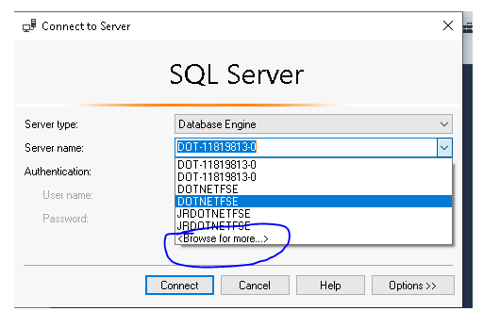

Expand Database Engine, click on the your VM DB name given there and click on ok.

